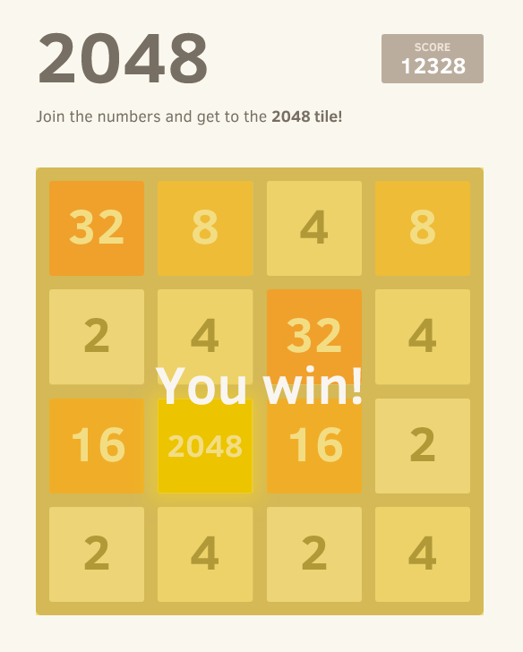2048

* A game solver that attempts to solve the game 2048 by achieving a 2048 tile while maximizing the efficiency and success rate.
* **Prolog Engine**: is responsible for:
* Taking the start position of 2048.
* Apply the search algorithm to get the path. This algorithm should be implemented in prolog.
* To avoid out of stack in this problem use limit depth.
* Send the results (all moves ) back to the user and print it in A brilliant GUI.
* The game is solved using Prolog as backend and Java GUI as frontend.
* The technique used to solve it is the Minimax Algorithm.